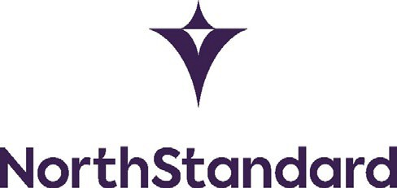

# MLC CERTIFICATES

**Application for Certificates of Financial Security under Regulation 2.5.2 Standard A2.5.2 and Regulation 4.2. Standard A4.2.1 paragraph 1 (b) of the Maritime Labour Convention 2006 (as amended) (“MLC Certificates”) pursuant to the Maritime Labour Convention Extension Clause 2024 (“MLC Extension Clause 2024”).**

If all vessels in the fleet

# Fleet name:

**OR**

**VESSEL NAME(S)** *(Please attach a schedule of vessels if necessary)*

# Period of Validity of Certificates

We request you to issue Certificates for the period noon GMT on 20 February 2024 to noon GMT on 20 February 2025

# Undertakings

1. We hereby undertake and agree that in consideration of the Club agreeing to issue the above Certificates at our request
   1. we know of no events or claims which may give rise to a demand under the MLC Certificates;
   2. we and all Joint Entrants will be bound by the terms of the **MLC Extension Clause 2024** which is deemed incorporated herein;
   3. where any payment by the Club under any such certificate is in respect of war risks, we will indemnify the Club to the extent that such payment is recoverable under the Member’s P&I war risks policy, or would have been recoverable if the Member had maintained and complied with the terms and conditions of a standard P&I war risks insurance policy;
   4. to assign to the Club all the rights of the Member under any social security scheme, or other insurance or national fund or other similar arrangement where such scheme, insurance, national fund or arrangement applies in respect of all or any liabilities arising under the MLC Certificates;
   5. 30 days from a notice to the Flag State of the termination thereof we shall take all necessary steps to remove the Certificates and any copies thereof from the vessel(s) and return them to the Club.
2. If we request Certificates prior to entry in the Club of the above vessel(s) being concluded for the 2024/2025 policy year*,* we further undertake that, in consideration of the Club providing upon our request the above Certificates for a period including the 2024/2025 policy year in order to ensure that such vessels are able to trade without delay and without the risk of penalties or fines for failing to satisfy MLC certification requirements
   1. it is our intention to enter the above vessel(s) in the Club or in another Club in the International Group of P&I Clubs for the 2024/2025 policy year; and
   2. if we do not effect such entry we will indemnify the Club and hold it harmless in respect of any and all liabilities, losses, damages, risks, costs or expenses which it may suffer or incur under MLC or implementing domestic legislation as a direct or indirect consequence of issuing the Certificates.
3. The above undertakings shall be governed by and construed in accordance with English law and any claim, dispute, legal action or proceeding arising out of or in connection with this letter of undertaking shall be subject to the exclusive jurisdiction of the High Court of Justice in London.
4. When called upon to do so, we will instruct solicitors in London to accept, on behalf of the Owners of any of the Vessels, as listed, service proceedings issued on behalf of the Club in connection with this undertaking.

# Date

Signed by Member on behalf of the Member and all Joint Entrants.

(if not signed by Member must be signed by authorised signatory of Member)